DynamoDB Assignment: -

**Problem Statement:**

You work for XYZ Corporation. Their application requires a database service that can store data which can be retrieved if required. Implement a suitable service for the same. While migrating, you are asked to perform the following tasks:

1. Create a DynamoDB table with partition key as ID.

2. Add 5 items to the DynamoDB table.

3. Take backup and delete the table.

**Procedure: -**

* Sign in to the AWS Management Console and navigate to the DynamoDB service.
* Click on "Create table."
* Enter the desired table name, such as "Kabi_Table".
* Specify "ID" as the partition key attribute name.
* Choose the data type for the partition key, such as "Number."
* Configure any other optional settings, such as read/write capacity units and encryption.
* Click on "Create."

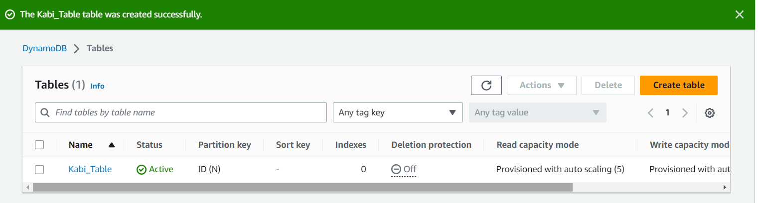

* Now select your table and click on “actions” and select “create item.”
* Give the value of partion key example 01.
* 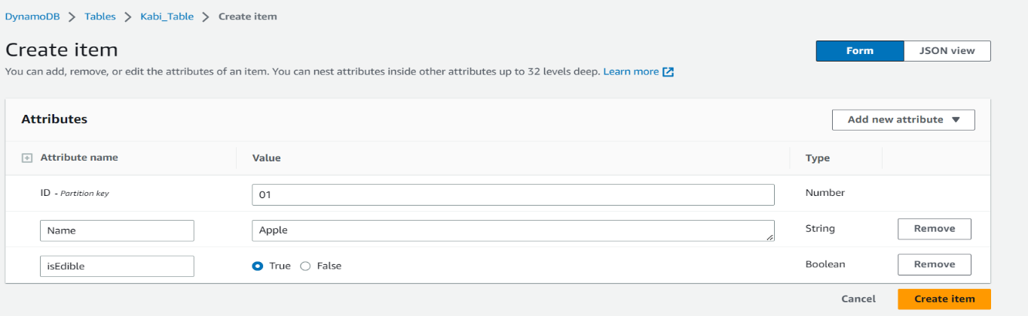Now you can instert the item my clicking on add “Add new attribute” and choosing the datatype.
* Click on “create item.”
* Therefore, one item is created. In the same manner we have to create the other items in the table.

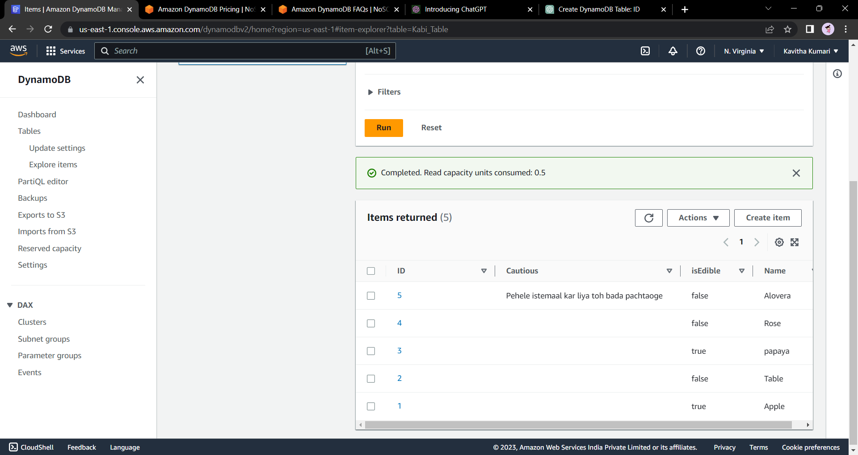

* To delete the table, select the table and click on delete, on the pop-up window you will see “Create an on-demand backup of Kabi_Table before deletion.”
* 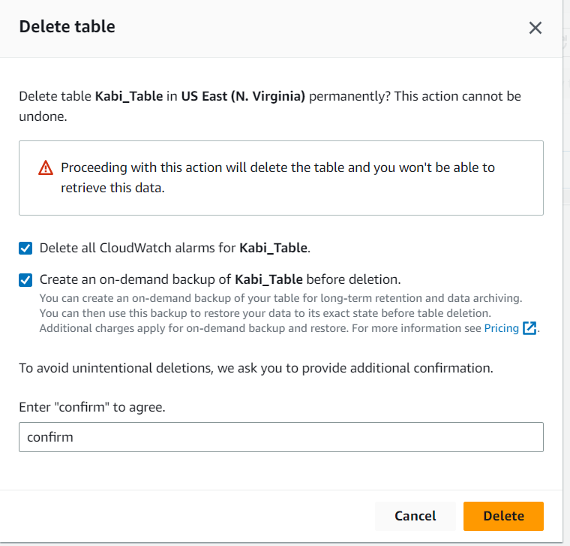Click that check box and delete the table.
* To see the back ups of the table you need to click on backups. There you will find the table and you can restore the table from there.

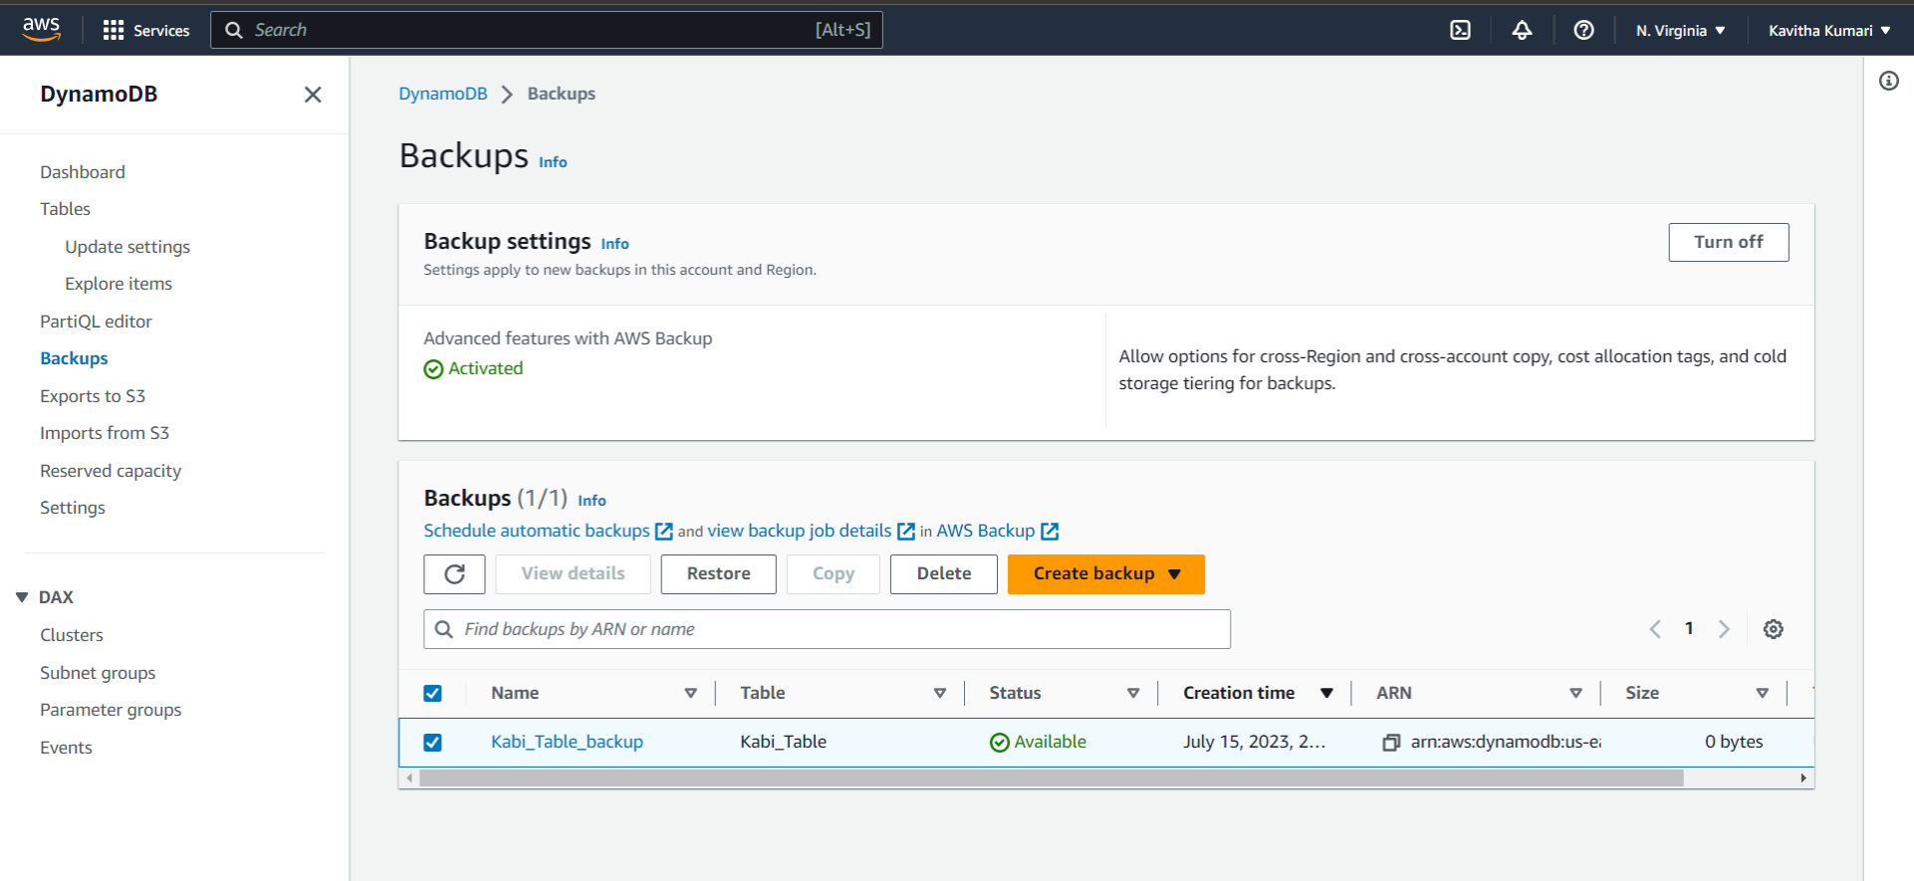

****--------------End------------